# Amplia's monthly investor letter

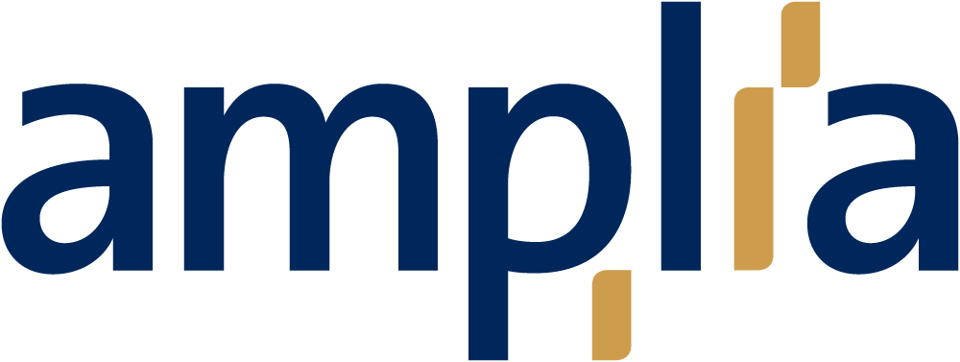

## The Cicones (Cicones)

The story of Odysseus' wanderings begins with his crew plundering the city of the Cicones after the Trojan War. After the plunder, the Greeks stay to celebrate – and during the night are attacked by the Cicones, who have gathered reinforcements. The symbolism is the price of greed and hubris.

The rounds of attacks by the White House on the Fed's sovereignty and the market's sudden ambivalence towards tariffs may in future history books be described as an excess of greed and hubris, where actors carelessly choose to look the other way. Are we in the midst of a wandering?

## Performance: Aeolus and the bag of winds (Aeolus)

The tailwind on the stock markets largely continued in August. Among the broader indices, only the S&P 500 and MSCI Emerging Markets posted negative returns. China (+8.8%) and Japan (+4.2%) stood out, as did small-cap companies in the US (+4.7%).



## *Source: Amplia, Bloomberg*

The fixed income market was more mixed: government bonds posted negative returns, while fixed income securities with higher credit risk fared better.

Macro: The Cyclops (Polyphemus)

The Jackson Hole symposium was held on August 21-23. As usual, academics and central bankers gathered to discuss current issues – and to engage in Kremlinology communication with the outside world. The biggest takeaway for the market was Powell's speech, which was interpreted as a tectonic shift in the Fed's approach: from keeping interest rates high to avoid inflation-driven growth damage, to emphasizing how lower interest rates should support growth even in an environment of higher inflation. A minor detail in the argument – which opens the gates of Hades to a central bank under the president's control. Low interest rates can support growth, but risk fuelling inflation (which in turn destroys growth) – especially when inflation is not met with higher unemployment.

At the same time, Trump has (attempted to) dismiss Lisa Cook from the Federal Reserve – the first time a sitting president has tried to dismiss a governor from the Board of Governors. Governor Cook has appealed, but the gauntlet has been thrown down: Trump wants control over the central bank.

The Fed's new stance from Jackson Hole means there is a risk that budget costs will skyrocket without growth picking up, while long-term interest rates rise – to the dramatic music of a potentially imminent Minsky moment. If the Fed really submits to the president's will, this could drive the US economy into a death spiral, poison the dollar as a reserve currency and at the same time strengthen the euro as the currency with the more credible central bank.

Europe is characterized by a relatively hot labor market (with the exceptions of Finland and Spain) but limited inflationary pressure. There is considerable uncertainty about the effects of tariffs on growth, which is why the ECB is likely to remain cautious about both rate hikes and cuts in the near future.

A weaker dollar – as a result of lower interest rates and growth in the US, combined with increased dollar caution abroad – would push for new growth pressure in Europe and, in line with a contagious recession from the US, give the ECB more room to cut rates. The ECB's Scylla and Charybdis are German stimulus measures starting in early 2026 and the US driving force in the form of tariffs and possible Chinese dumping.

Valuation: Circe (Circe)

Broad stock indices are close to historic highs, while investment appetite outside AI is subdued. Both Europe and the US are in a precarious situation due to uncertainty about the impact of US tariffs. Europe fears weaker demand from across the Atlantic, while the US is more concerned about what higher, persistent inflation could mean in terms of interest rates and predictability.

While the P/E ratio in the US (S&P 500) is above 24, Europe (Stoxx 600) is just below 16. This means that any disappointment in growth, inflation and/or risk premium – given the same magnitude – will reasonably hit the US stock market about 1.5 times harder.

The valuation reflects, especially in the US, a Goldilocks scenario where AI drives productivity that compensates for any slack in the rest of the economy. This makes the market vulnerable to rapid shifts in sentiment.

Sentiment: Sirens (Sirenes)

Sentiment remains strong. Despite a market dip in early August, the VIX has remained close to the 15 level, still well above realized volatility of 10-12%. Given the uncertainty surrounding the economy and tariff outcomes, the market appears relatively hot. Since the downturn that began around the turn of January-February and lasted until Trump's retreat from “liberation day,” markets have rebounded 19-33% (in local currency), even though the threat to the global economy has largely been re-established. So we are in almost the same nightmare as in April – but with a much more optimistic outlook.

When sentiment is strong, the market is strong; the most likely daily movement is up. It's like the familiar game of musical chairs: keep dancing while the music plays – but avoid being the last one standing when it stops. Even if everyone thinks the music has been playing for a long time, you have to keep dancing and wait for the real signal.

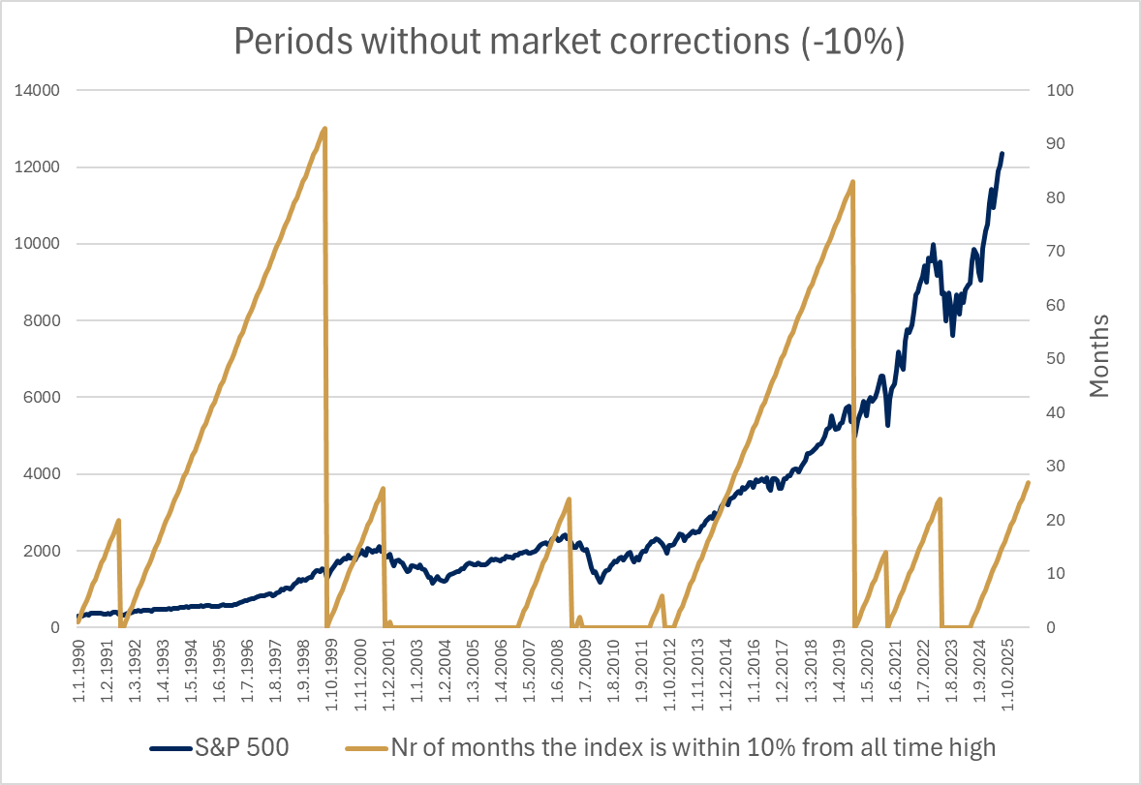

*Historical data shows that the average length of periods without market corrections (−10% from peak) is around 2½ years.*

Allocation: The Phaeacians (Phaeaces)

Although the temptation to underweight equities/risk was strong when the earth seemed to shake in early August, we have sat on our hands during the month. Our investment in the MSCI World Health Care ETF demonstrated for the first time the diversification benefit we had anticipated it would provide, as it recovered by more than 5% after the month's convulsions, compared with a mediocre 1.5% in the S&P 500.

Despite heated sentiment and high valuations, especially in the US, we have chosen to remain overweight in equities and risk in general. Tactically, it may be worthwhile to reduce exposure somewhat if more significant clouds of concern appear in the form of negative macro news, but without an explicit reason, we are not underweighting risk. Fear is a poor investment strategy.

So far, the 2025 stock market year resembles Odysseus' wanderings in many ways: the only certainty about the remaining four months is uncertainty itself. We hope to reach safe harbor at the end of the year – but we are always prepared for change.

1 September 2025

Kind regards

Mikael Simonsen

P.S. A recurring, somewhat entertaining habit has been to place our monthly comments in an external frame – opera, card games, navigation, etc. Since Odysseus' wanderings were taking over the text, this time the analogies will remain between the lines.